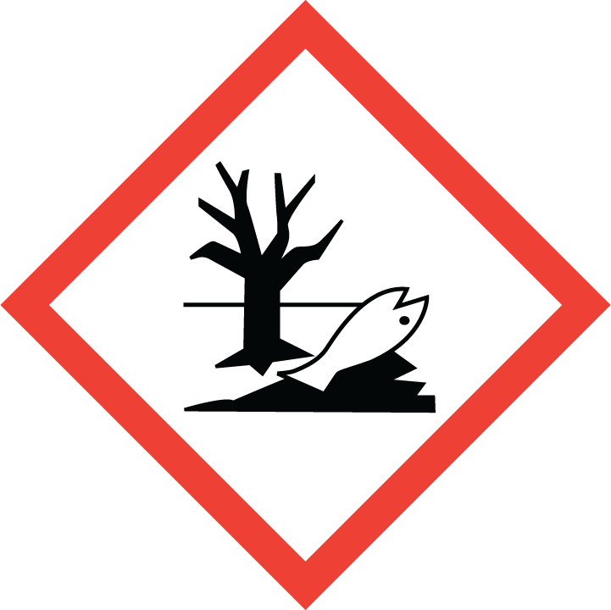
TOXIC TO AQUATIC LIFE

